Rectangular-Region Generator

Definition
# Source: AI Source: Provided by: [Data Path: Persons Table -> ID Column: 1, Name_En Column: Motasem Essam] -> From: [ChatGPT] on [7/25/2026]
A Rectangular-Region Generator is a plane-region generator that uses a rectangular area as its generating region to produce three-dimensional solids through rotation, translation, extrusion, or other spatial movements.
The most common application is rotating a rectangular region around one of its sides to generate a Right Circular Cylinder.
A rectangle can also generate other solids depending on the position and type of movement applied to it.
Important distinction:
- A rectangular region has a two-dimensional area and generates a solid when swept through space.
- A rectangular boundary consists only of four line segments and generates surfaces rather than a filled solid when swept.

Geometric Representation
# Source: AI Source: Provided by: [Data Path: Persons Table -> ID Column: 1, Name_En Column: Motasem Essam] -> From: [ChatGPT] on [7/25/2026]
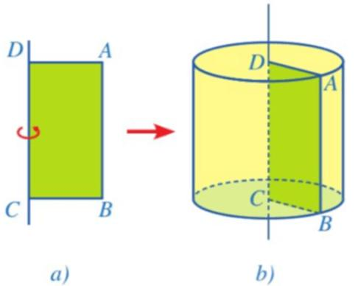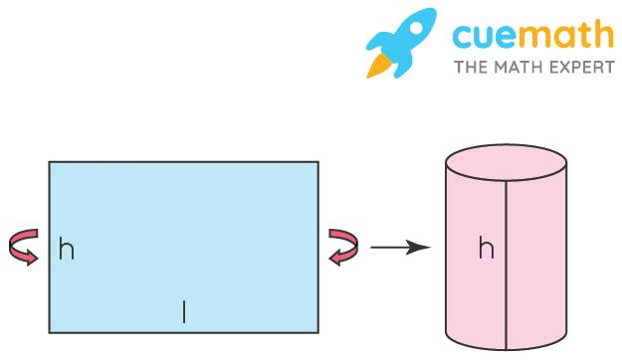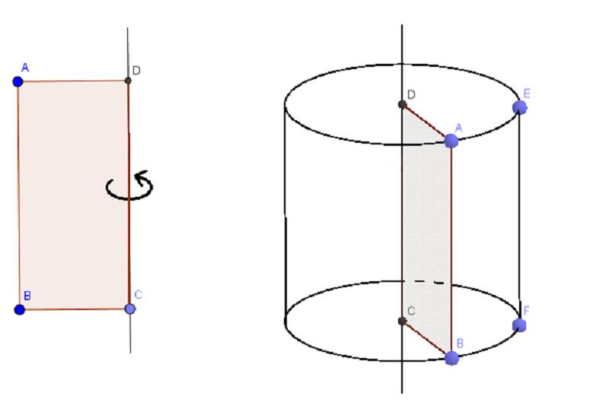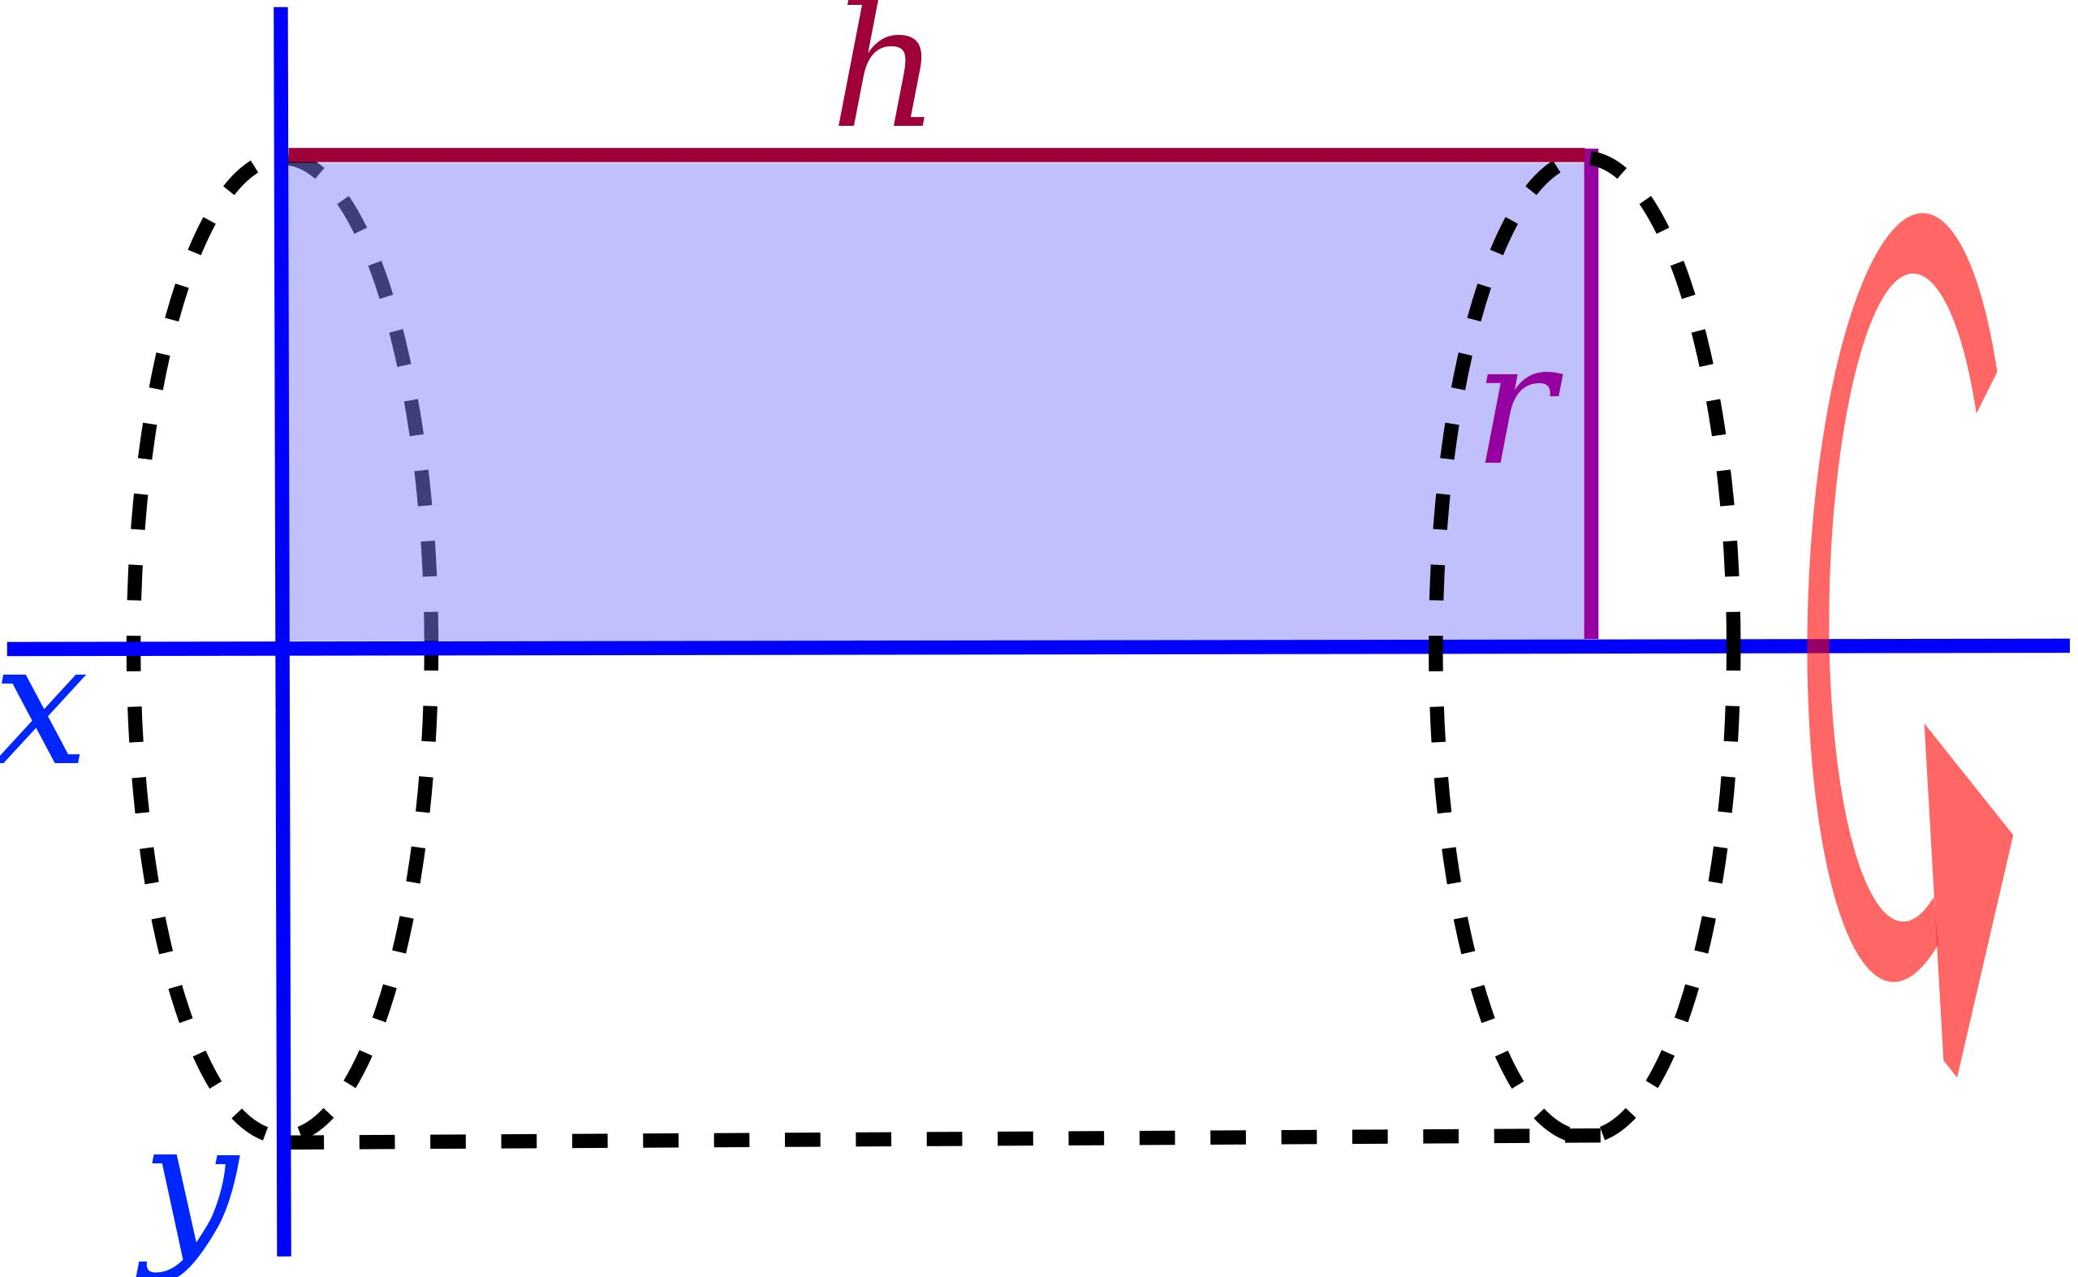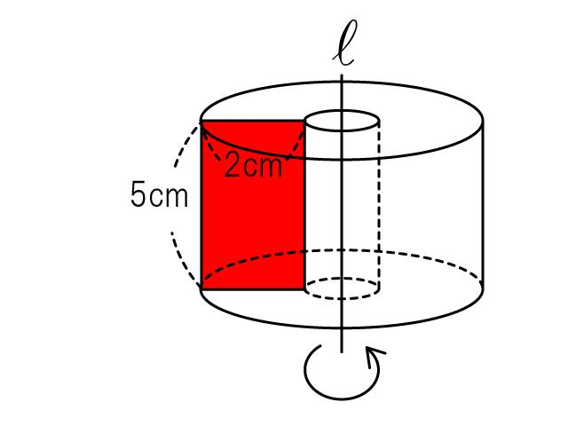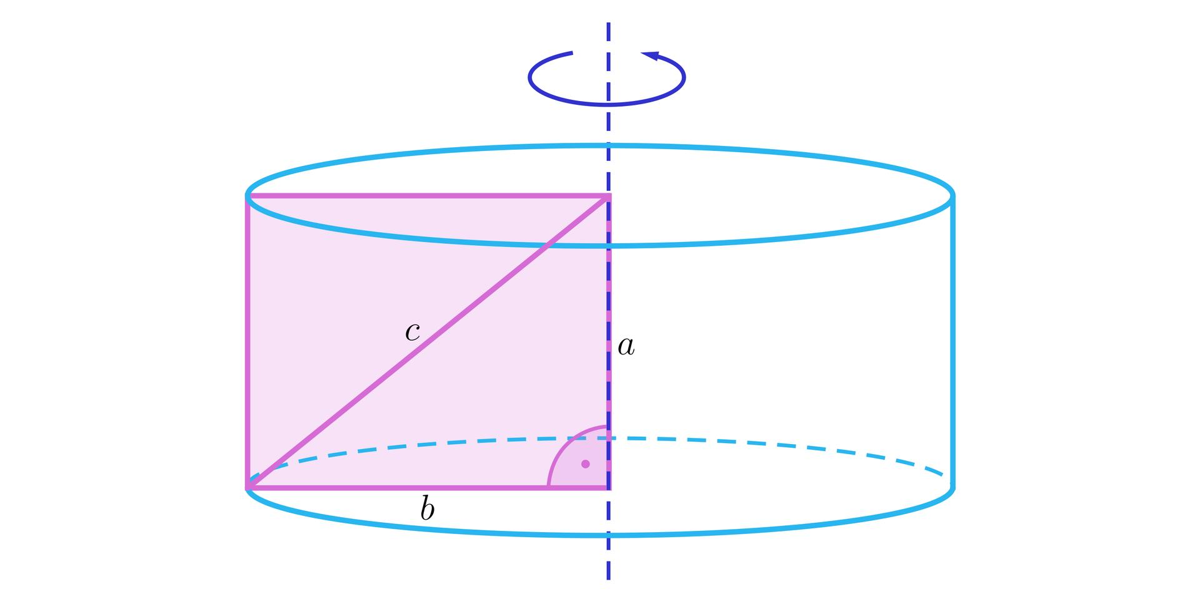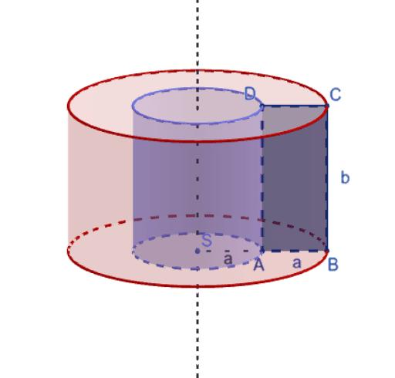
A rectangular region is defined by four sides, four right angles, and a fixed area. Its generated three-dimensional form depends on the movement and the selected axis.

Geometric Structure
# Source: AI Source: Provided by: [Data Path: Persons Table -> ID Column: 1, Name_En Column: Motasem Essam] -> From: [ChatGPT] on [7/25/2026]
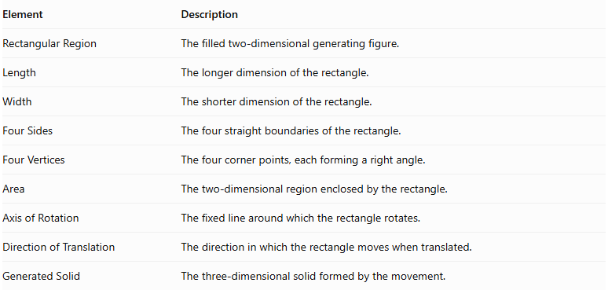
Element | Description
Rectangular Region | The filled two-dimensional generating figure.
Length | The longer dimension of the rectangle.
Width | The shorter dimension of the rectangle.
Four Sides | The four straight boundaries of the rectangle.
Four Vertices | The four corner points, each forming a right angle.
Area | The two-dimensional region enclosed by the rectangle.
Axis of Rotation | The fixed line around which the rectangle rotates.
Direction of Translation | The direction in which the rectangle moves when translated.
Generated Solid | The three-dimensional solid formed by the movement.

Types of Rectangular-Region Generators According to Movement

Rotational Rectangular-Region Generator
# Source: AI Source: Provided by: [Data Path: Persons Table -> ID Column: 1, Name_En Column: Motasem Essam] -> From: [ChatGPT] on [7/25/2026]
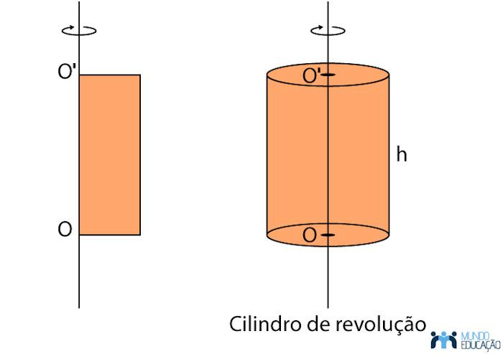
A rectangular region rotates around a fixed axis to generate a solid of revolution.
A. Rotation Around One of Its Sides
- Generates a right circular cylinder.
- The side on the axis determines the cylinder's height.
- The perpendicular side determines the cylinder's radius.
B. Rotation Around an External Parallel Axis
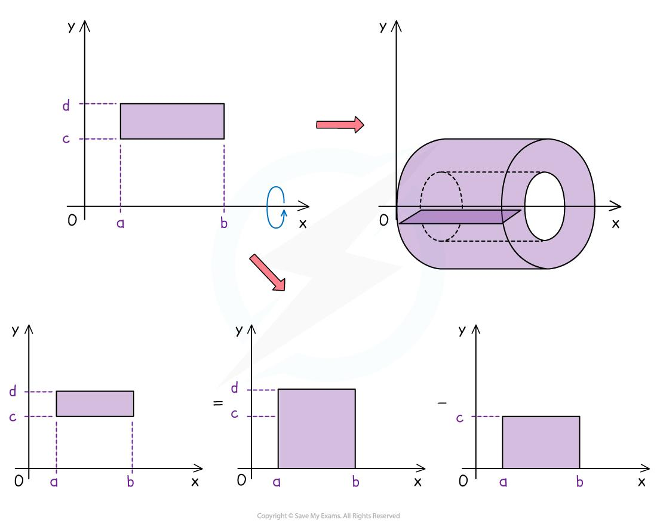
- Generates a hollow cylindrical solid with an annular cross-section.
- The distance from the axis to the nearer side determines the inner radius.
- The distance from the axis to the farther side determines the outer radius.
C. Rotation Around an Axis Through the Rectangle's Center and Parallel to One Pair of Sides
- Generates a cylinder if the axis lies in the rectangle's plane and passes through its center.
- The cylinder's radius is half the perpendicular dimension of the rectangle.
- Its height is the dimension parallel to the axis.

Translational Rectangular-Region Generator
# Source: AI Source: Provided by: [Data Path: Persons Table -> ID Column: 1, Name_En Column: Motasem Essam] -> From: [ChatGPT] on [7/25/2026]
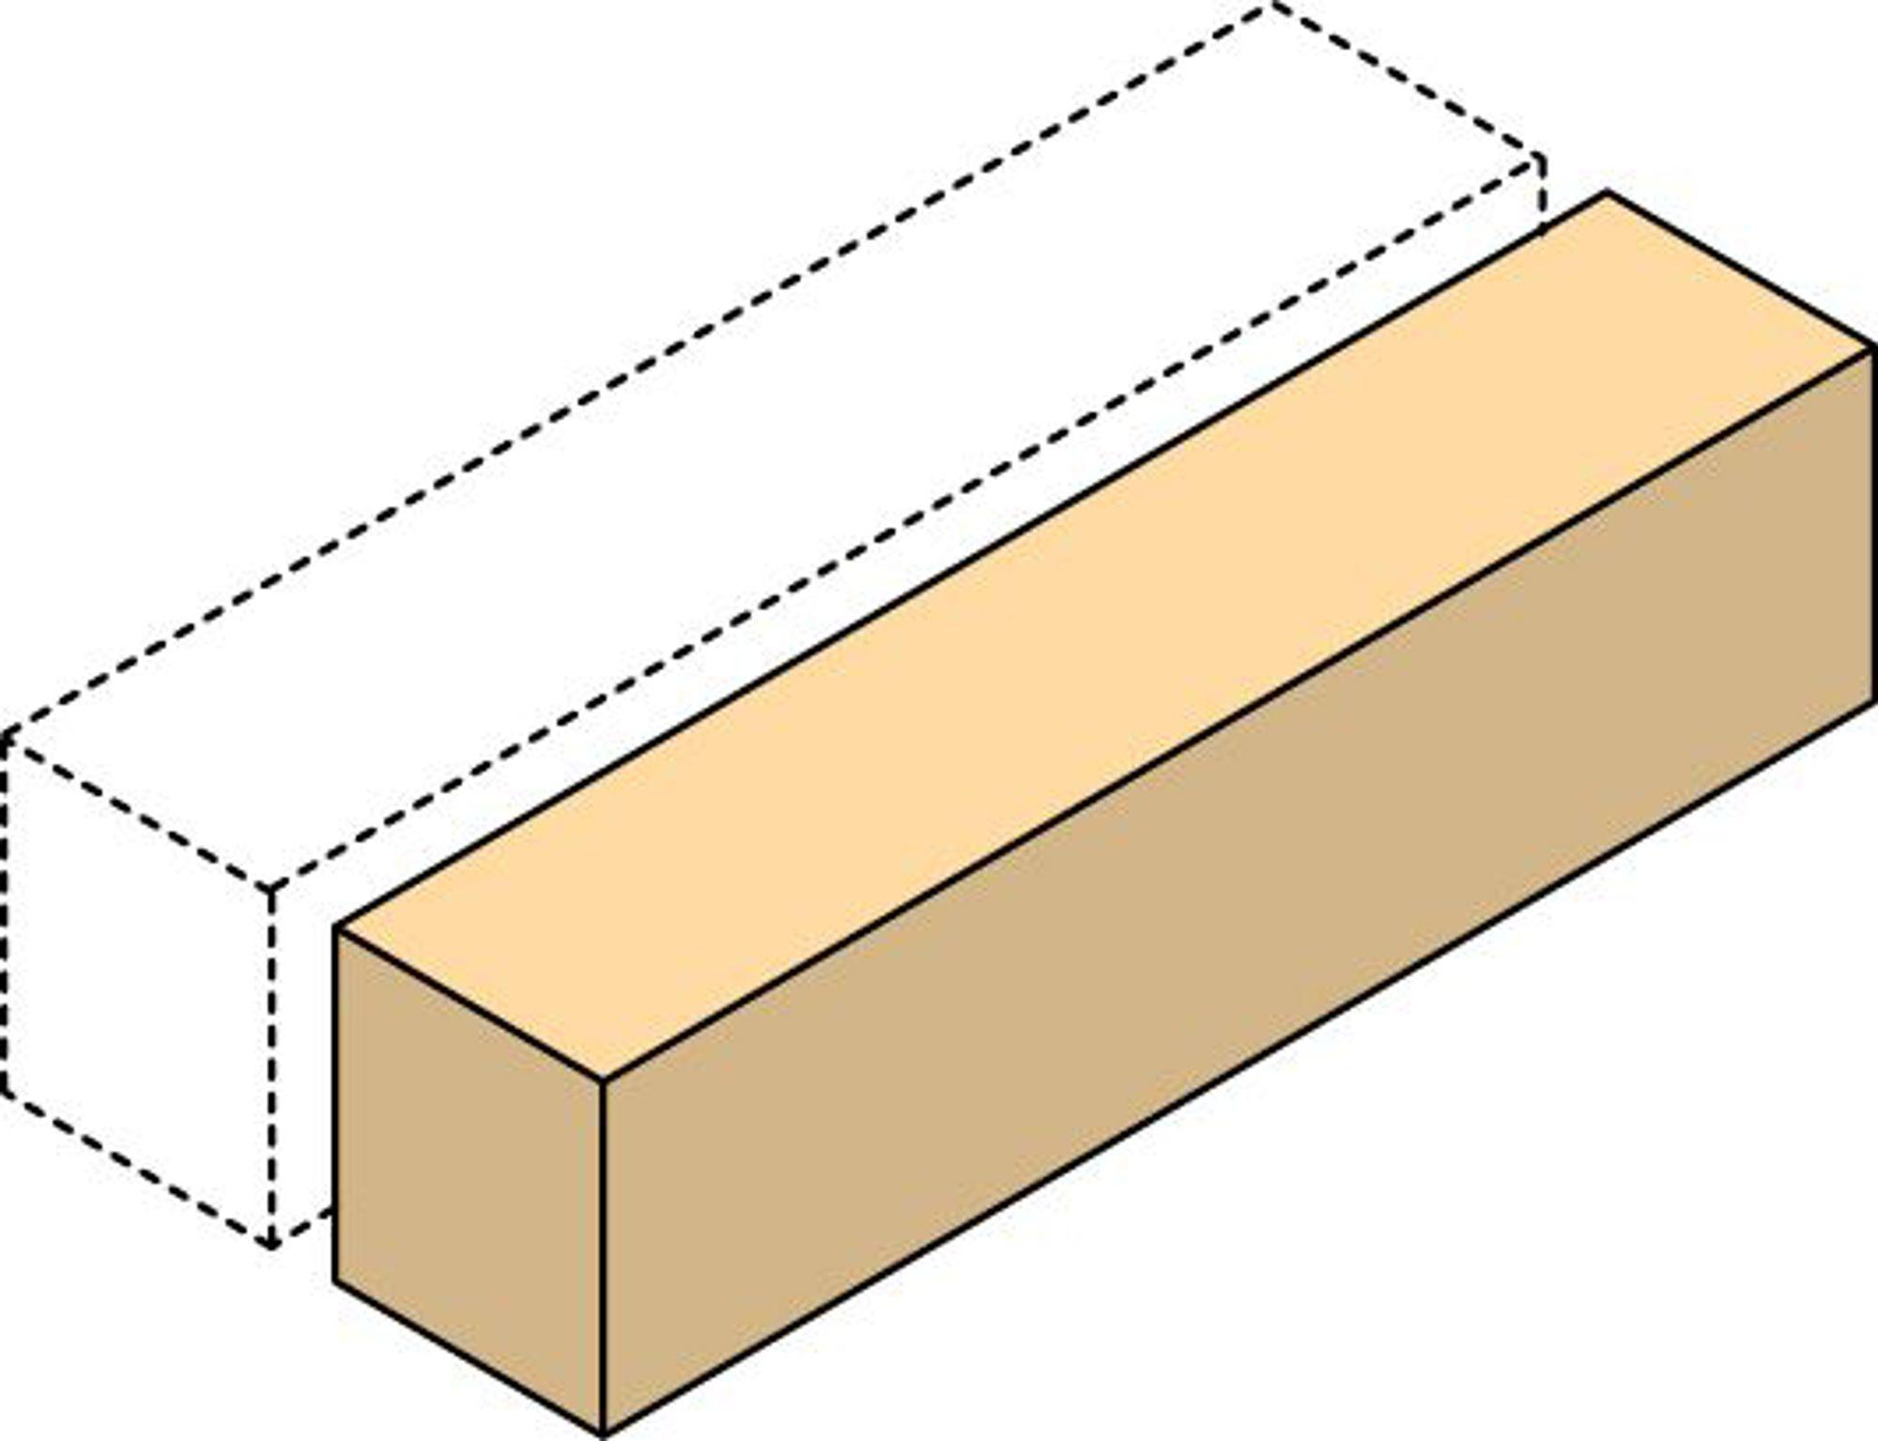
A rectangular region moves along a straight direction without rotating.
When the translation direction is perpendicular to the plane of the rectangle, it generates a Rectangular Prism (Cuboid).
Characteristics:
- The original rectangle forms one end face.
- The translated rectangle forms the opposite end face.
- The connecting faces are parallelograms; they are rectangles when the translation is perpendicular to the original region.
- The translation distance determines the prism's height or length.

Combined Rotational and Translational Rectangular-Region Generator
# Source: AI Source: Provided by: [Data Path: Persons Table -> ID Column: 1, Name_En Column: Motasem Essam] -> From: [ChatGPT] on [7/25/2026]
A rectangular region can undergo rotation and translation simultaneously.
The resulting solid depends on the path and orientation of the region during its movement. Such motion can generate more complex swept solids and should not be classified as a standard cylinder or prism without specifying the motion.

Mathematical Representation
# Source: AI Source: Provided by: [Data Path: Persons Table -> ID Column: 1, Name_En Column: Motasem Essam] -> From: [ChatGPT] on [7/25/2026]
Let a rectangle have:
- Length $L$
- Width $W$
- Area $A$
Its area is:
$$A=L×W$$

Rotation Around One Side
# Source: AI Source: Provided by: [Data Path: Persons Table -> ID Column: 1, Name_En Column: Motasem Essam] -> From: [ChatGPT] on [7/25/2026]
Suppose the rectangle rotates around its length $L$.
The resulting cylinder has:
$$h=L, r=W$$
Its volume is:
$$V=πW^{2}L$$
Its curved surface area is:
$$A_{c}=2πWL$$
Its total surface area is:
$$A_{t}=2πW(L+W)$$
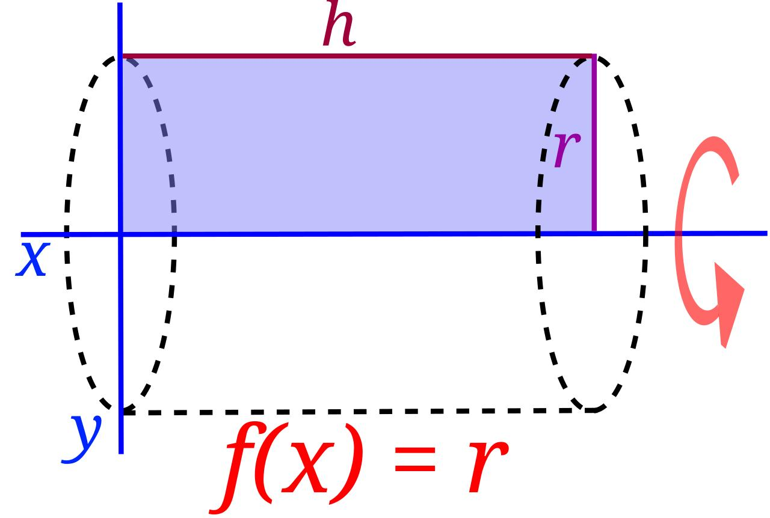

Rotation Around an External Parallel Axis
# Source: AI Source: Provided by: [Data Path: Persons Table -> ID Column: 1, Name_En Column: Motasem Essam] -> From: [ChatGPT] on [7/25/2026]
Suppose the axis is parallel to the rectangle's length and is at a distance $d$ from its nearer side.
The rotation generates a hollow cylindrical solid with:
$$r_{\text{inner}}=d$$
$$r_{\text{outer}}=d+W$$
Its volume is:
$$V=πL(r_{\text{outer}}^{2}-r_{\text{inner}}^{2})$$
Substituting:
$$V=πL[(d+W)^{2}-d^{2}]$$

Translation Perpendicular to the Rectangular Region
# Source: AI Source: Provided by: [Data Path: Persons Table -> ID Column: 1, Name_En Column: Motasem Essam] -> From: [ChatGPT] on [7/25/2026]
If the rectangle is translated perpendicularly through a distance $H$, it generates a rectangular prism.
Its volume is:
$$V=LWH$$
Its total surface area is:
$$A_{t}=2(LW+LH+WH)$$
Its space diagonal is:
$$D=\sqrt{L^{2}+W^{2}+H^{2}}$$
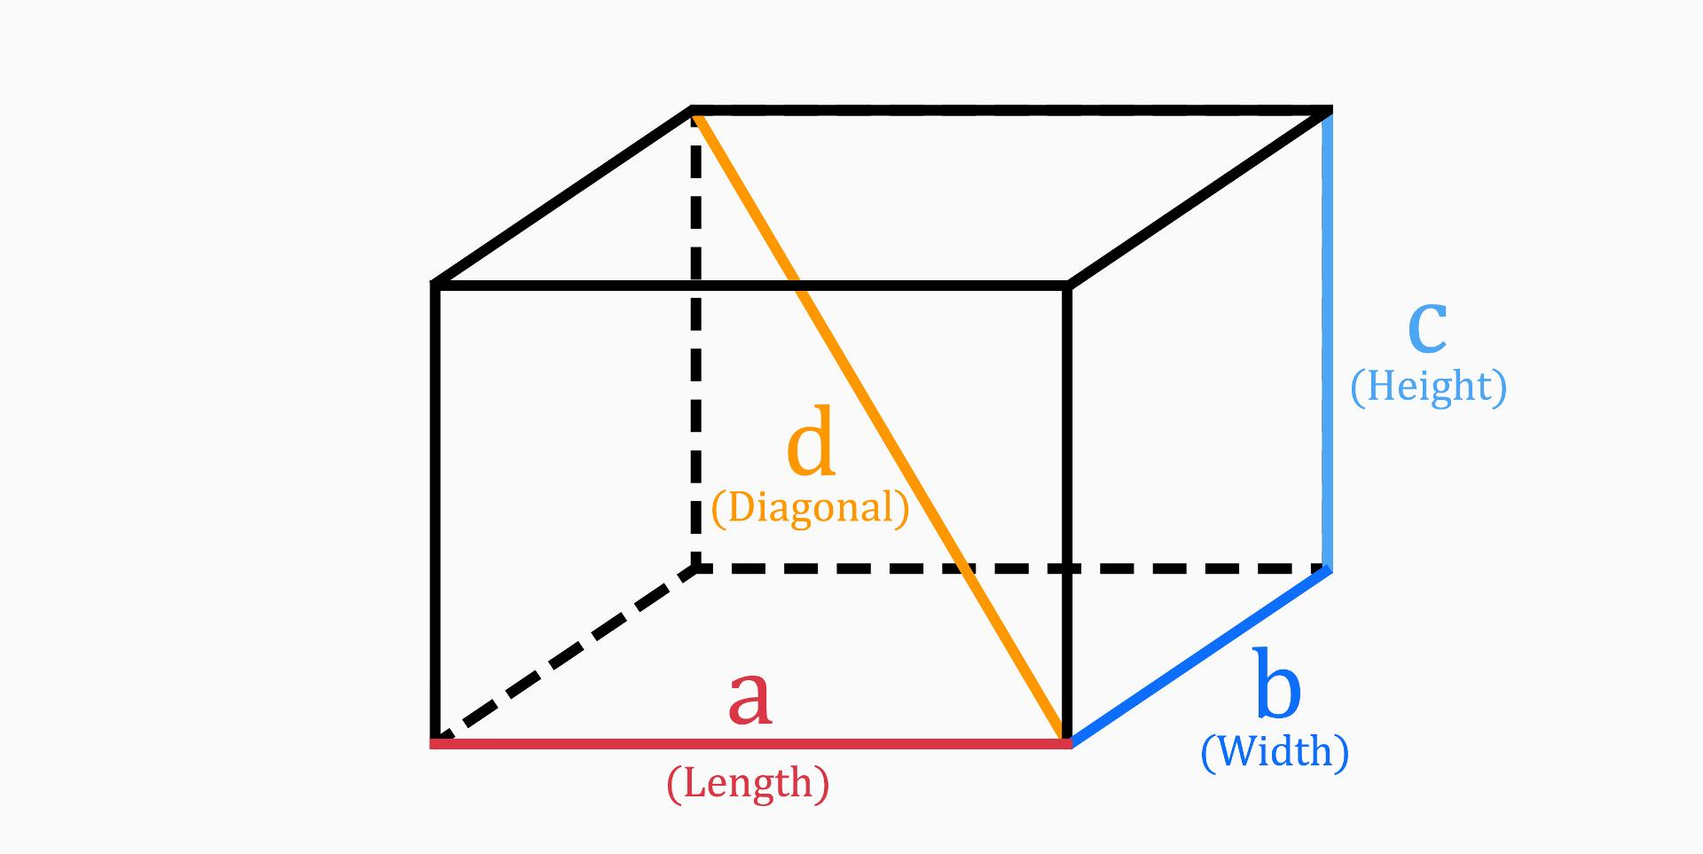

Oblique Translation
# Source: AI Source: Provided by: [Data Path: Persons Table -> ID Column: 1, Name_En Column: Motasem Essam] -> From: [ChatGPT] on [7/25/2026]
If the rectangle is translated along a direction that is not perpendicular to its plane, it generates an oblique prism.
Its volume is:
$$V={LWH}_{⊥}$$
Where $H_{⊥}$ is the perpendicular distance between the two parallel rectangular end faces.
The translation distance alone is not necessarily the prism's perpendicular height.

Mathematical Properties
# Source: AI Source: Provided by: [Data Path: Persons Table -> ID Column: 1, Name_En Column: Motasem Essam] -> From: [ChatGPT] on [7/25/2026]
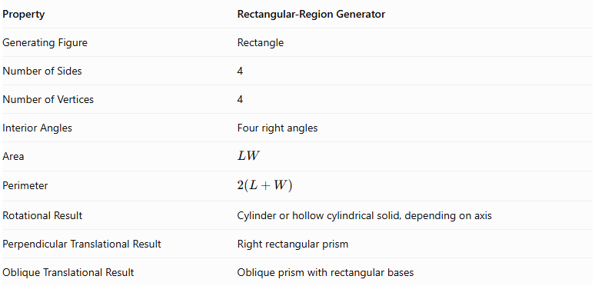
Property | Rectangular-Region Generator
Generating Figure | Rectangle
Number of Sides | 4
Number of Vertices | 4
Interior Angles | Four right angles
Area | $$LW$$
Perimeter | $$2(L+W)$$
Rotational Result | Cylinder or hollow cylindrical solid, depending on axis
Perpendicular Translational Result | Right rectangular prism
Oblique Translational Result | Oblique prism with rectangular bases

Generated Surfaces and Solids

Right Circular Cylinder
# Source: AI Source: Provided by: [Data Path: Persons Table -> ID Column: 1, Name_En Column: Motasem Essam] -> From: [ChatGPT] on [7/25/2026]
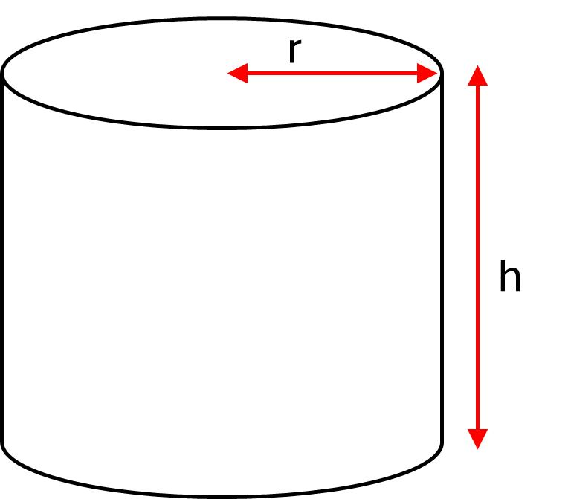
Generated by rotating a rectangular region around one of its sides.

Hollow Cylindrical Solid
# Source: AI Source: Provided by: [Data Path: Persons Table -> ID Column: 1, Name_En Column: Motasem Essam] -> From: [ChatGPT] on [7/25/2026]
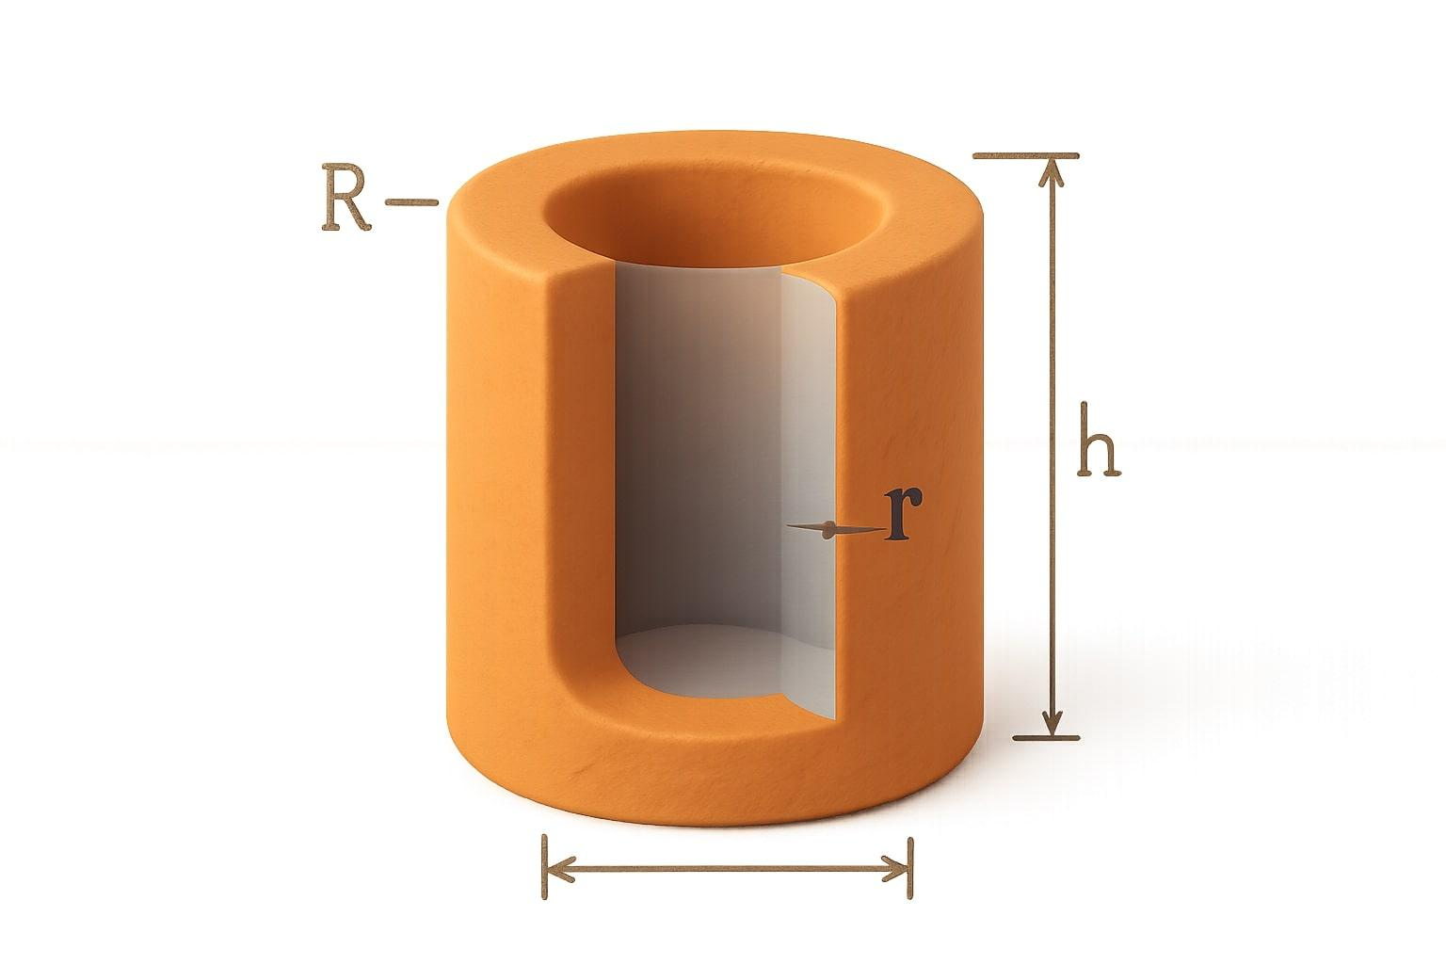
Generated by rotating a rectangular region around an external axis parallel to one of its sides.

Rectangular Prism (Cuboid)
# Source: AI Source: Provided by: [Data Path: Persons Table -> ID Column: 1, Name_En Column: Motasem Essam] -> From: [ChatGPT] on [7/25/2026]
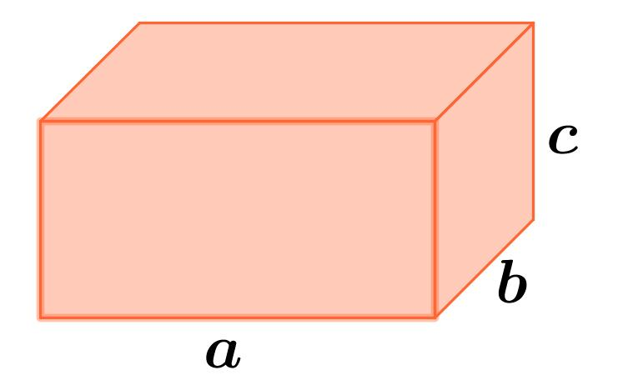
Generated by translating a rectangular region perpendicularly to its plane.

Oblique Rectangular Prism
# Source: AI Source: Provided by: [Data Path: Persons Table -> ID Column: 1, Name_En Column: Motasem Essam] -> From: [ChatGPT] on [7/25/2026]
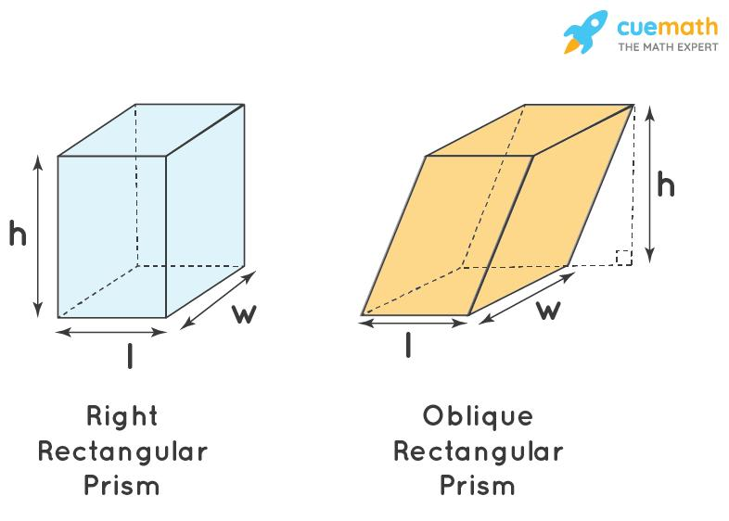
Generated by translating a rectangular region in an oblique direction relative to its plane.

Applications
# Source: AI Source: Provided by: [Data Path: Persons Table -> ID Column: 1, Name_En Column: Motasem Essam] -> From: [ChatGPT] on [7/25/2026]
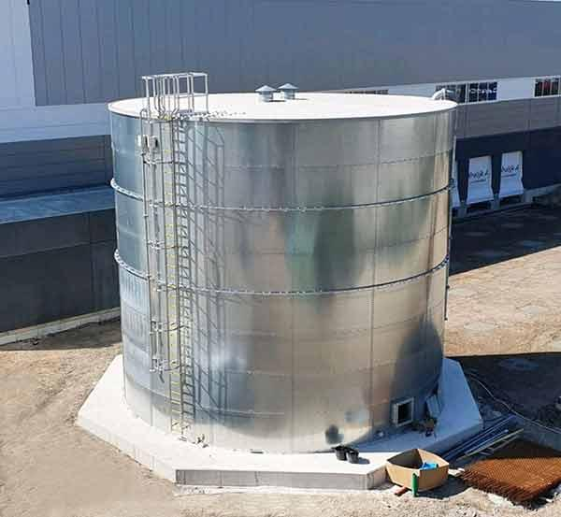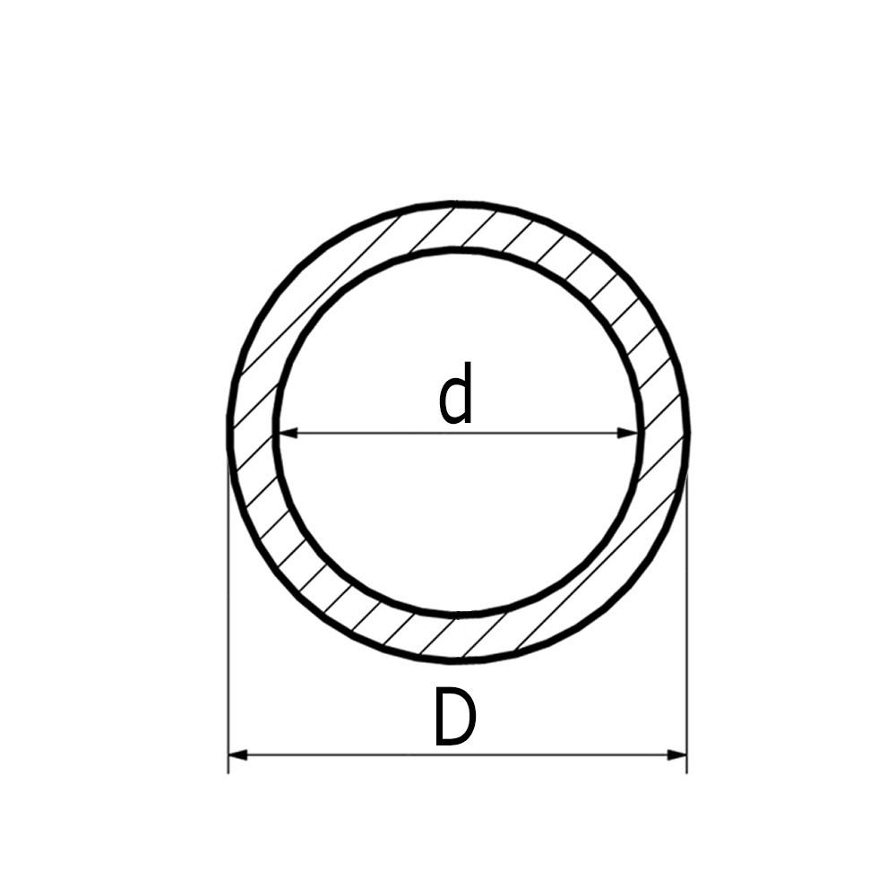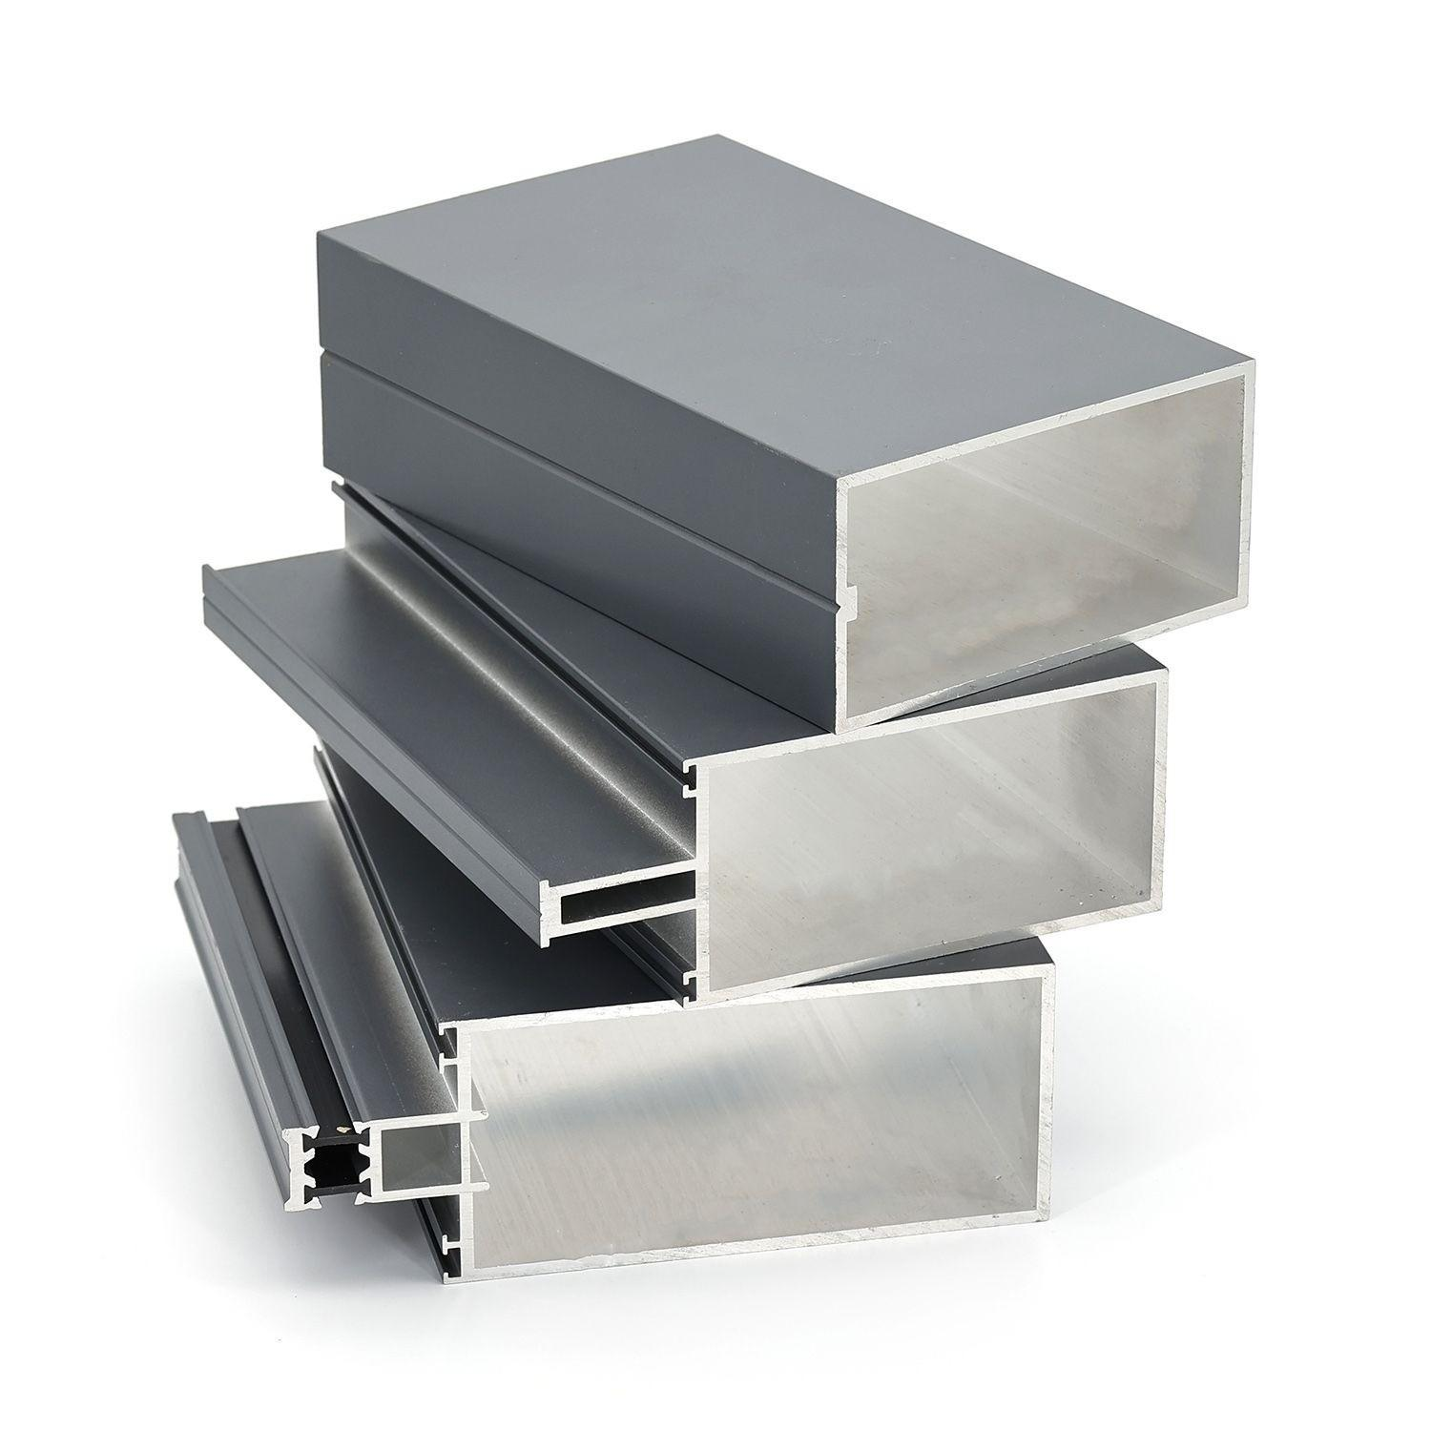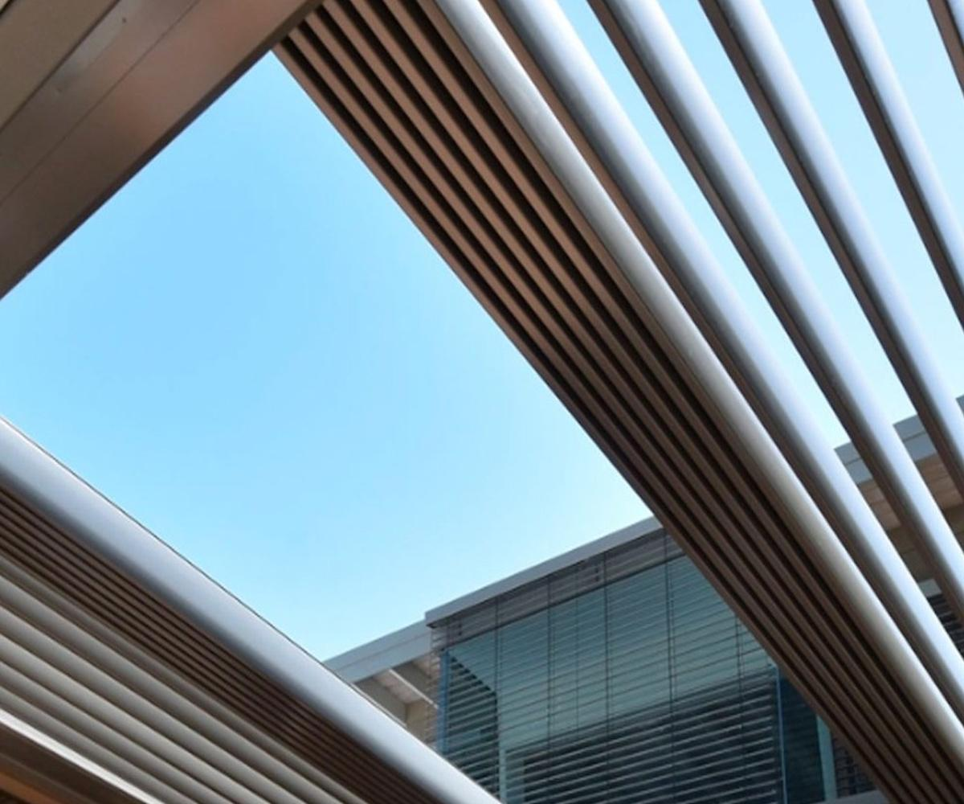
- Cylindrical Containers: Tanks, cans, and cylindrical storage vessels.
- Hollow Cylindrical Components: Pipes, sleeves, and cylindrical housings.
- Rectangular Containers: Boxes, storage units, and packaging.
- Extrusion and Manufacturing: Producing prismatic components from rectangular cross-sections.

Comparison with Other Plane-Region Generators
# Source: AI Source: Provided by: [Data Path: Persons Table -> ID Column: 1, Name_En Column: Motasem Essam] -> From: [ChatGPT] on [7/25/2026]
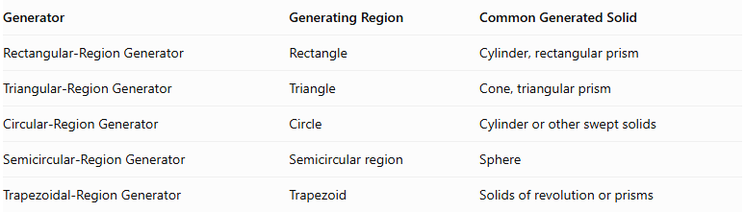
Generator | Generating Region | Common Generated Solid
Rectangular-Region Generator | Rectangle | Cylinder, rectangular prism
Triangular-Region Generator | Triangle | Cone, triangular prism
Circular-Region Generator | Circle | Cylinder or other swept solids
Semicircular-Region Generator | Semicircular region | Sphere
Trapezoidal-Region Generator | Trapezoid | Solids of revolution or prisms

Main Classification
# Source: AI Source: Provided by: [Data Path: Persons Table -> ID Column: 1, Name_En Column: Motasem Essam] -> From: [ChatGPT] on [7/25/2026]
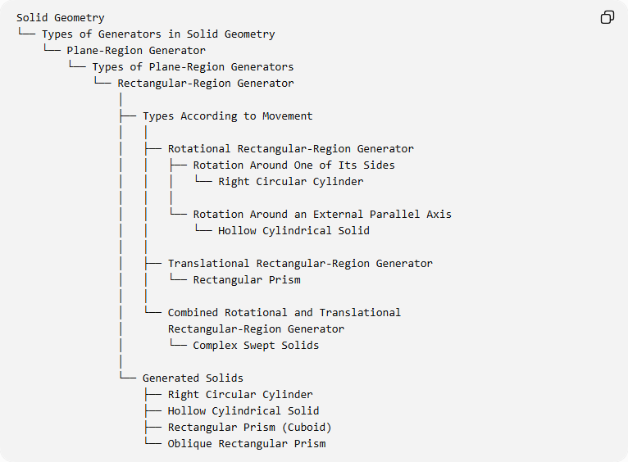
Solid Geometry
└── Types of Generators in Solid Geometry
└── Plane-Region Generator
└── Types of Plane-Region Generators
└── Rectangular-Region Generator
│
├── Types According to Movement
│ │
│ ├── Rotational Rectangular-Region Generator
│ │ ├── Rotation Around One of Its Sides
│ │ │ └── Right Circular Cylinder
│ │ │
│ │ └── Rotation Around an External Parallel Axis
│ │ └── Hollow Cylindrical Solid
│ │
│ ├── Translational Rectangular-Region Generator
│ │ └── Rectangular Prism
│ │
│ └── Combined Rotational and Translational
│ Rectangular-Region Generator
│ └── Complex Swept Solids
│
└── Generated Solids
├── Right Circular Cylinder
├── Hollow Cylindrical Solid
├── Rectangular Prism (Cuboid)
└── Oblique Rectangular Prism

Key Points
# Source: AI Source: Provided by: [Data Path: Persons Table -> ID Column: 1, Name_En Column: Motasem Essam] -> From: [ChatGPT] on [7/25/2026]
- A rectangular-region generator uses a filled rectangle to generate three-dimensional solids.
- Rotating a rectangle around one of its sides produces a right circular cylinder.
- Rotating a rectangle around an external parallel axis produces a hollow cylindrical solid.
- Translating a rectangle perpendicularly to its plane produces a rectangular prism.
- Oblique translation produces an oblique prism.
- The resulting solid depends on the movement, direction, and axis of the generating region.
- A rotating rectangular boundary and a rotating filled rectangular region generate different geometric results.

Conclusion
# Source: AI Source: Provided by: [Data Path: Persons Table -> ID Column: 1, Name_En Column: Motasem Essam] -> From: [ChatGPT] on [7/25/2026]
The Rectangular-Region Generator is a fundamental plane-region generator in solid geometry. Its rectangular generating area can produce cylindrical solids through rotation and prismatic solids through translation.

